|  |  |  |
| --- | --- | --- |
| 2/16/23, 7:58 PM | Service Catalog - PISA |  |
| **Profile Card update: "Works with" section removal** |

CHG0054057 (All RBU's) - Deactivation of the People insights feature is going to be performed on Atos Azure PRD tenant on 17-02-2023. When you select someone's name or picture in Outlook or other Oice apps, you can find information related to people on their profile card. The "Works with" section in the "Organization" tab will no longer be visible. Therefore, it won't be possible to see the set of individuals who the owner of the profile card "works with". As added information, it could take few days for the change to be propagated across the tenant.



**[Home](https://pisa.myatos.net/home?id=index)**  **[IT](https://pisa.myatos.net/home?id=git_services&sys_id=45a9884f1bc1c8107c1ddceacd4bcb86)**  **[Identity & Security](https://pisa.myatos.net/home?id=git_services&sys_id=34a9884f1bc1c8107c1ddceacd4bcb5a)**  **[SSO (Login with PKI, OTP, DAS)](https://pisa.myatos.net/home?id=git_category&sys_id=e6a90c4f1bc1c8107c1ddceacd4bcbb5)**  **Add an application to the SSO system**

|  |  |  |
| --- | --- | --- |
| |  |  | | --- | --- | | How can we help? |  | |
| Add an application to the SSO system |

|  |
| --- |
| Requested For |

|  |  |
| --- | --- |
|  | Nitish Tewari |
|  | |

|  |  |
| --- | --- |
| Organization | |
|  | India |
|  | |

|  |  |
| --- | --- |
| Description   https://pisa.myatos.net/home?id=sc_cat_item&sys_id=884a1f051bd8e05014bd42eacd4bcbd6 | 1/4 |

|  |
| --- |
| Add an application to the SSO system |
|  |

|  |
| --- |
| Summary |

|  |  |
| --- | --- |
| 2/16/23, 7:58 PM | Service Catalog - PISA |

Want to Register an SSO with an application that deals with the documentation upload during on borading of the selected employees.

Application Name (What is the descriptive name for the application?) 

Hiring Documentation Portal

Application description (Short description of the functional features provided by the application)

Hiring Documentation Portal is a document and data submission portal which takes the data and documents of the selected candidate for further data processing.

Application users (Who are the target users?)

|  |  |
| --- | --- |
| Others |  |

Application business ownership 

|  |  |
| --- | --- |
|  | |
| 4SPL  Business contact   Lijo George  List of users who need access to STG   Lijo George  Neha Saxena  Technical contact   If the contact is an external supplier, please provide a Technical Contact from Atos also)  User name, DAS ID, mail address and/or telephone number"  https://pisa.myatos.net/home?id=sc_cat_item&sys_id=884a1f051bd8e05014bd42eacd4bcbd6 | 2/4 |

|  |  |
| --- | --- |
| (Who acts as the contact(s) from technical operations and support perspective? |  |

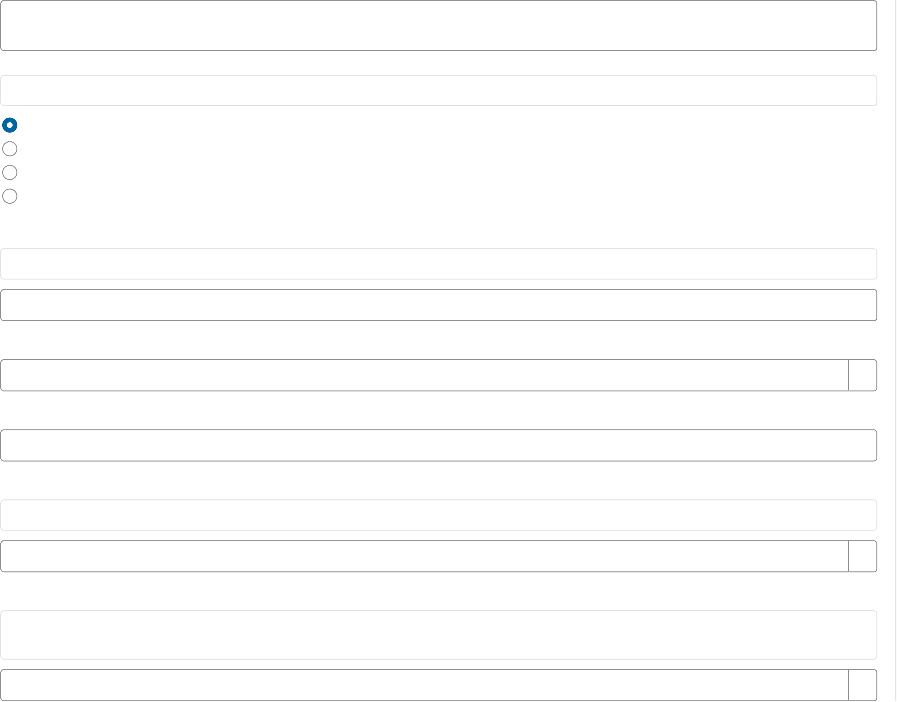

2/16/23, 7:58 PM Service Catalog - PISA

Baswaraj Salwadi A722576 baswaraj.salwadi@atos.net

Nitish Tewari A861203 nitish.tewari@atos.net

Hosting 

(How is the application hosted? Where is the application hosted? Specify cloud or on-prem data center location)

OnPrem

SaaS

PaaS

IaaS

Expected Usage 

(What is the expected usage? Estimate how many people will logon per day/week/month)

100/week

Is the application managing Personal Data?

Yes

If YES, then is the CADP-C Validated?

YES

Authentication strength 

(Select the required multi-factor policy)

[default] Conditional MFA (use MFA when employee is enabled for MFA)

Authentication Protocol 

(Which protocol endpoint will be used by the

application to authenticate? Specify SAML 2.0 or WS-Fed as protocol. (OpenID Connect / OAuth is not supported)

SAML 2.0

https://pisa.myatos.net/home?id=sc_cat_item&sys_id=884a1f051bd8e05014bd42eacd4bcbd6 3/4

2/16/23, 7:58 PM Service Catalog - PISA

|  |
| --- |
| Geographical Scope (global or particular country) |

|  |
| --- |
| India |
|  |

|  |  |
| --- | --- |
| Claims configuration  |  |
| (Which information is required in the claim (token)? |  |

Default information provided to the application in the claim is:  
· Subject (NameID) [contains DAS ID]  
· Uid [DAS-ID]  
· Email address  
· First name  
· Last name

|  |
| --- |
| Specify if less or more information is required in the claim) |

|  |
| --- |
|  |
| Default Information |

*Allowed file extensions in attachment are: xls, xlsx, doc, docx, pdf, png, jpg, jpeg, msg, xlsm, ppt, pptx, svg, txt, pac, har, enc, zip, 7z, csv, eml **Privacy (Data Protection Information Notice)**

|  |
| --- |
| **© Atos S.E. 2023 all rights reserved. Reproduction in whole or in part is prohibited without the written consent of Atos S.E.** Submit |

Submitting...

|  |  |
| --- | --- |
|  | |
| https://pisa.myatos.net/home?id=sc_cat_item&sys_id=884a1f051bd8e05014bd42eacd4bcbd6 | 4/4 |